**Do Violent Video Games affect School Grades of Children?**

Bellevue University

Term Project: Milestone 2

DSC500: Introduction to Data Science

Felipe Rodriguez

October 9, 2022

**Do Video Games affect School Grades of Children?**

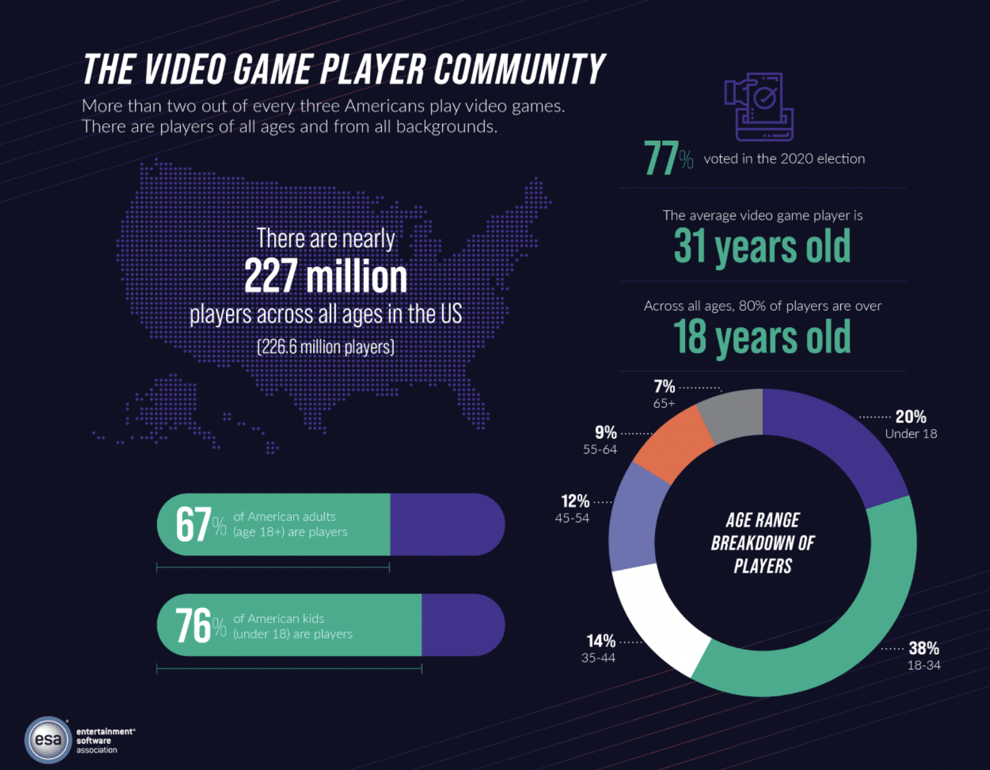As technology has advanced, there has been an increasing amount of video games that are made available to children. Children can play video games on consoles, computers, or even their mobile devices. According to the Electronic Software Association, in 2021 76% of children in the United States play video games (Entertainment Software Association, 2021). With the number of children playing video games, parents should know the effects of them. Especially when it comes to school and their grades. Understanding these correlations can help parents limit time spent on video games or encourage video games that promote brain development. With this, children can find a balance between a hobby and school, which can hopefully lead to success.

Figure (Entertainment Software Association, 2021)

Video games, according to Marriam-Webster, is ‘an electronic game in which players control images on a video screen.” (2022) There are violent and non-violent video games. A violent video game is a “video game which includes depictions of or simulations of human-on-human violence in which the player kills or otherwise causes serious physical harm to another human” (Violent Video Game Definition, 2022). Since games can be of different types, how are they distinguished amongst each other? Games are designated a rating so that the purchaser is aware of the content the video game could have. The ESRB, or Entertainment Software Rating Board (formally known as Interactive Digital Software Association), created by the Entertainment Software Association in 1994 (ESRB), is the association responsible for rating video games. The ESRB has several different ratings, but the most common seen in video games are Rating E- Everyone, Rating T- Teens 13 and up, and Rating M- Mature for people 17 and up. The video games Rated M are rated as such because they feature more violence and sexual content (Chivers, 2021). Of these different ratings, most games are rated E.

Figure (Chivers, 2021)

With most video games being Rated E, how does do these ratings affect parental decisions when purchasing video games for their children? These ratings designate a guideline for buyers so there are no surprises when they start up their new video game.

Do violent video games and regular video games affect children differently?

Because there are different types of ratings in video games, there could be a difference in the way that regular video games and violent video games affect children. For example, regular video games can enhance problem solving skills when obstacles arise in the game they are playing (Institute for Educational Advancement, 2022). Being able to apply problem solving early on can bring benefits to children in the future. There is also the availability of online play or local play. With this, video games can create an opportunity for socialization, and improve the social skills (Institute for Educational Advancement, 2022).

On the other hand, video games can have some negative effects on children. Children who are exposed to violent video games can “become immune to violence and are more inclined to act violently themselves.” (Institute for Educational Advancement, 2022) This can create hostile situations at home and at school. Another negative effect that video games can have on children, is it can potentially lower their performance at school (Institute for Educational Advancement, 2022) This brings up the questions how big is the grade difference between those who play video games and those who do not? Some video games promote problem solving and math to complete the game while others do not.

Google trends shows that searches for “video game playing” and “failing school” have a correlation (see image below, data source Google Trends). People seemed to be interested in these two topics and how video games affect school grades. A study conducted shows that children with “new video games spend more less time doing homework and do worse in standardized testing”Chart, line chart
(Dewar, 2022). This study conducted provides good insight on the issue but was only conducted on 64 children who have never owned video games before. Because the children had never owned video games before, part of the decrease in grades could have been from the excitement of owning video games for the first time, which would be a factor that would need to be considered. What is needed next in this study, or a study that can be conducted separately, is seeing how children who already have video games versus those who have never had them. The thrill of a new item and already having video games could make a difference on how school grades are being affected.

Another study done by Vivek Anand (2007) finds that there is a correlation between amount of time spent playing video games and GPA and SAT scores. “As video game usage increases, GPA and SAT scores decrease. Jancee Wright also conducts a study on video games and GPA. This study was conducted with 198 participants who filled out a survey. Wright’s study finds that those who did play videos games had lower GPAs (Wright, 2011). Wright mentions that the study conducted does not account for any outside activities, which could include sports, work, or course load.

Conclusion

The effects of the different categories of videos can be either positive or negative in children. The two studies presented earlier give good fundamental information that is needed to understand what the effects of video games are on school grades. However, they lack some parameters to have more conclusive data. Parameters such as schoolwork load, work schedules, extracurricular activities or personalities. Understanding differences in the effects of video games can play a key role is parents’ decisions on what kind of entertainment parents expose their kids to. Further investigation will be needed on grades and students and comparing them to those who use video games and those who don’t. Another item to research will be the long-term effects of video games and how children who practiced them turned out. These two studies will provide more answers and give more information on the role of video games and student grades.

Reference:

Anand, V. (2007, August 21). *A study of time management: The correlation between video game usage ...* A Study of Time Management: The Correlation between Video Game Usage and Academic Performance Markers. Retrieved October 9, 2022, from https://www.liebertpub.com/doi/abs/10.1089/cpb.2007.9991

Chivers, K. (2021, January 14). *2020 video game ratings in review, and what they mean to gamers*. Norton. Retrieved September 15, 2022, from https://us.norton.com/internetsecurity-kids-safety-video-game-ratings.html

Dewar, G. (2022, March 13). *The effects of video games on School Achievement*. PARENTING SCIENCE. Retrieved October 9, 2022, from https://parentingscience.com/effects-of-video-games-on-school/

Entertainment Software Association. (2022, February 7). 2021 Essential Facts About the Video Game Industry. Retrieved September 15, 2022, from <https://www.theesa.com/resource/2021-essential-facts-about-the-video-game-industry/>).

Merriam-Webster. (2022, September 4). *Video game definition & meaning*. Merriam-Webster. Retrieved September 15, 2022, from https://www.merriam-webster.com/dictionary/video%20game

*Our history*. ESRB Ratings. (2021, December 9). Retrieved October 9, 2022, from https://www.esrb.org/history

*The good and the bad effects of video games on children*. Institute for Educational Advancement. (2022, May 21). Retrieved September 15, 2022, from https://educationaladvancement.org/blog-the-good-and-the-bad-effects-of-video-games-on-children/

*Violent video game definition*. Law Insider. (n.d.). Retrieved September 15, 2022, from https://www.lawinsider.com/dictionary/violent-video-game

Wright, Jancee (2011) *"The effects of video game play on academic performance*," Modern Psychological Studies: Vol. 17: No. 1, Article 6.  
Available at: https://scholar.utc.edu/mps/vol17/iss1/6